- Food safety is a scientific discipline describing proper handling, preparation and storage of food in ways that prevent foodborne illness (due to pathogenic microorganisms)

Why is Food Safety Important?
- Food is expected to nourish people
- Unsafe foods lead to foodborne diseases which are mainly induced by micro-organisms
- Some populations are highly vulnerable to unsafe foods

Types of hazards to food safety
Physical: = Hard or soft foreign objects in food that can cause illness and injury They include items such as fragments of glass, metal, toothpicks, jewelry, adhesive bandages, and human hair.

Chemical = Toxic substances that may occur naturally or may be added during the processing of food.
They include:
- Agricultural chemicals (e.g. pesticides, herbicides and fertilizers)
  - Industrial chemicals (Excess additives, lubricants, migration of plasticizers, ink or adhesive from packaging, antibiotics, hormone residues, dioxin and PCB )
  - Cleaning compounds
  - Heavy metals (e.g. lead and mercury)
  - Natural toxins
- NOTE: chemicals and other non-food items should never be placed near food items.
Dioxin and PCB:
- Chlorine or benzene containing chemicals
- By-products of industrial processes and the incineration of waste products.
- They increase the risk of cancer.
- Food sources are animal fats and fish from dioxin-contaminated waterways.
- They do not degrade quickly in the environment

Biographical:
Include bacteria, viruses, parasites and fungi (= yeasts and molds) that are living organisms that are so small they can only be seen with the aid of a microscope microorganisms also known as “microbes” or “germs”.
- They are by far, the most important food-borne hazard in any type of food establishment and are the primary target of a food safety program.
- The microorganisms that cause most food borne illnesses are bacteria

What are Pathogenic Microorganisms?
Food provides ideal conditions for microorganisms:
Nutrients
Moisture
Warmth (4°C to 57°C)
- These microorganisms get their energy from the food in which they live and reproduce.
- Many occur naturally in the environment where foods are grown .
- Most are destroyed by adequate cooking, and numbers are kept to a minimum by proper cooling during product distribution and storage.
Biological hazards may:
- Be Pathogenic = Disease-causing
- Cause Spoilage = do not cause disease, only reduce the quality of food to unacceptable levels. E.g. some molds

Foodborne Illnesses
- It is a special kind of food deterioration that may or may not alter a food’s sensory properties. It is due to pathogenic microorganisms.
- Food infections: involve microorganisms present in the food at time of consumption, which then grow in the host and cause illness. Caused by some bacteria (ex: Salmonella), all viruses and all parasites
- Toxin-mediated infections: caused by eating a food that contains harmful microorganisms that will produce a toxin once inside the human body. Caused by some bacteria
- Food intoxications: involve toxic substances produced in foods as by-products of microorganisms prior to consumption and cause disease upon ingestion. Also termed food poisoning. Caused by some bacteria

Where can Pathogenic Microorganisms come from?
- Purchased foods
- Home-grown foods
- Indoor and outdoor animals
- Water
- Your environment

Symptoms: (similar to stomach-flu symptoms):
- Headache- Abdominal pain- Nausea- Diarrhea- Vomiting- Fatigue- Dehydration- Fever
A variety of people may face these special risks:
  - Fetuses of Pregnant women
  - Very young children
  - People with chronic illnesses or weakened immune systems
  - Older adults

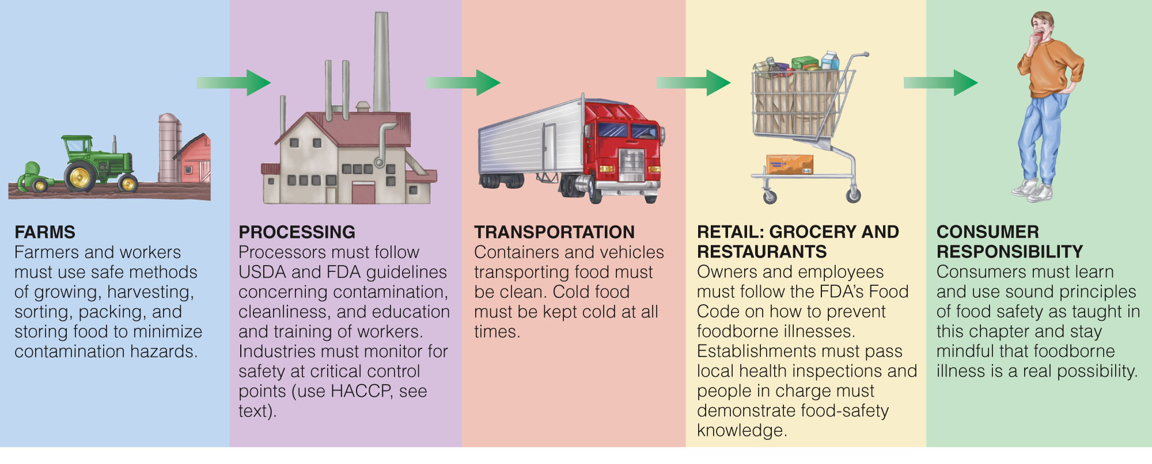
Flow of Food Safety: From Farm to Table

Consumer Responsibility: Steps to Keep Food Safe:
- Clean:
- Clean hands :
- Remove major grime first by rinsing in warm water.
- Lather hands with soap.
- Rub palms, between fingers and back of hands and up the wrist at least 2 inches.
- Rub for at least 20 seconds.
- Rinse in clean, warm water.
- Dry completely using a clean cloth or paper towel.

When to wash hands?: When you return home. After using the rest room. Before preparing or eating any food. After smoking, sneezing, blowing your nose or coughing. After changing diapers. Any other time your hands might have been contaminated.

- Clean fresh products :
- Choose whole fruits and vegetables over pre-cut and packaged.
- Don’t cut fresh produce until you are ready to prepare them for a meal.
- Prepare only the amount you can eat in one meal.

- Separate
- Avoid Contaminating Food
- Avoid Contaminating the Home Environment
- Separate raw meat, poultry and seafood from other foods in your grocery shopping cart
- Place ready-to-eat- food on top and raw meat, poultry and seafood at the bottom of your refrigerator
- Use different cutting boards for raw meats and ready-to-eat foods. If not possible, clean and sanitize between different foods

- Cook : Adequately
  - The only accurate way to determine if most foods are cooked to safe temperatures is to use a food thermometer.
  - Use a clean food thermometer to make sure meat, poultry and other foods are properly cooked all the way through (avoid partially cooked food).
  - Cook eggs until yolk and white are firm.
  - Fish should be opaque and flake easily with a fork.
  - Reheat leftovers thoroughly (ONLY ONCE!)

- Chill
- Keep Freezer at -18°C or Lower
- Keep Refrigerator 4°C or lower

- Refrigerate or freeze perishables, prepared food and leftovers within 2 hours of preparation.
- Divide large amounts of leftovers into shallow containers for quick cooling in the refrigerator.
- Use a thermometer to make sure refrigerator is below 4°C.

- Never thaw foods at room temperature (refrigerator).
- Marinate foods in the refrigerator.
- Don’t pack the refrigerator too full. Cold air must circulate to keep food safe.
- Use refrigerated meat in 1-2 days; frozen in 3-4 months

- Avoiding Microbes at the Store
- Buy frozen, perishable foods last
- Place meats in separate plastic bags
- Don’t buy dented cans
- Buy only pasteurized milk/cheese
- Buy only what you need
- Avoid buying slimy, brownish, or dry produce

